FPGA-based CNN Accelerator for Real-Time Handwritten Digit Recognition

CNN consists of the following major stages:
1. Convolution Layer
2. ReLU Activation Layer
3. Max-Pooling Layer
4. Fully Connected (Dense) Layer
5. Argmax Output Layer

Input image size (grayscale image) = 28 x 28
→ Convolution (16 kernels of size 3×3)
→ ReLU Activation
→ Max Pooling (2×2)
→ Flattening
→ Fully Connected Layer
→ Argmax Classification Output
Convolution layer : purpose is to extract meaningful features such as edges, curves, and patterns from the input image.
We are gonna use :
16 convolution kernels
Kernel size = 3 × 3
Stride = 1
No padding

we have 28x28 image and kernel size is 3
so 0 to 27 is width = height of the image

if we slides our filter on image then last valid pixel can go till 25 as 25 26 27 this value will be fetched by our 3x3 kernel
so after kernel operation we will get 26*26 feature map for each kernel [0-25 in total 26]

Each kernel slides across the 28 × 28 input image and performs element-wise MAC operation.

Mathematically convolution :

Y(i,j) : This is the output value at position (i,j).
i = row number
j = column number

X = image input
W = Filter / Kernel [filter checks for some feature (like vertical edge, shape).]
b = bias [extra number added to end] final answer = sum + bias
K = filter size
m = row inside filter
n = column inside filter

This is the image patch:
X(i+m,j+n)

Steps to perform convolution

1. Place filter on image
Choose output position (i,j) and place kernel there.

2. Take image patch
Pick the same-sized patch from image.
Example for 3×3 filter:
3×3 image patch

3. Multiply matching values
Multiply each image pixel with corresponding filter value.
pixel × weight

4. Add all products
Sum all multiplied values.
Σ (all products)

5. Add bias
Add one extra constant.
sum + b

6. Store output
This becomes:
Y(i,j)
one output pixel.

7. Slide filter
Move filter right by 1.
Repeat steps 2–6.

8. Complete entire image
After scanning all valid positions, output feature map is ready.

ReLU : Remove negative values.
- if x > 0 → keep it
- if x < 0 → make it 0
negative activations are usually not useful for feature detection

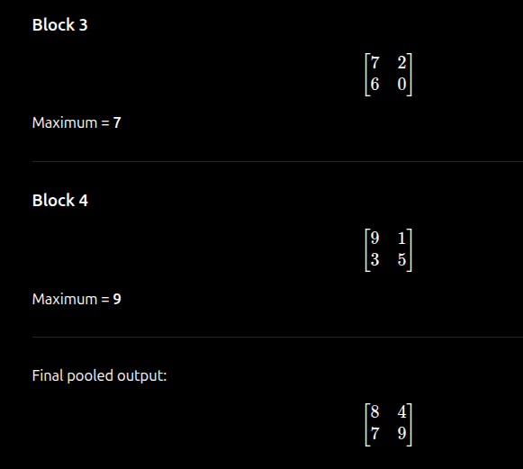
Max-Pooling : Take a small region and keep only the largest value.

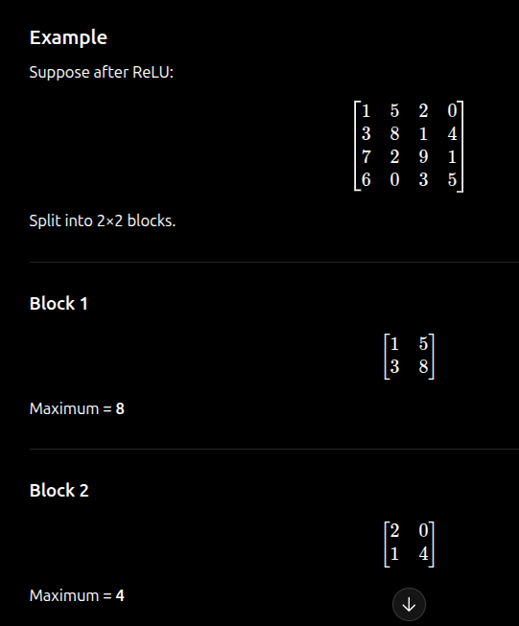

Max pooling reduces feature map size.
26×26
↓
13×13

Input : 28×28×1
Conv(16,3×3) : 26×26×16
ReLU : 26×26×16
MaxPool(2×2) : 13×13×16
Flatten : 2704
Fully Connected : 10
Argmax : predicted digit

output of pooling layer converted into flatten 1-D vector and passed it to fully connected layer (dense layer) which decides digits 0 to 9 by calculating weighted sum for each neuron

Dense layer formula :
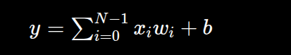

Where:
- i = 0 to N-1 → go through all inputs
- xᵢ → input feature
- wᵢ → corresponding weight
- b → bias
- y → output score
- N → total flattened inputs

after this there will be arg max function which will pick max value out of 10 given by dense layer

CNN Calculation for 28×28 Input Image
Assumptions:
- Input image = 28 × 28
- Number of kernels = 16
- Kernel size = 3 × 3
- Stride = 1
- No padding
- Max Pooling = 2 × 2

Step 1: Input Layer
Input image size: 28 × 28 × 1
(1 channel because grayscale image)
Total input pixels:
28 × 28 = 784

Step 2: Convolution Output Size
Formula:
Output size = N − K + 1
Where:
N = 28
K = 3
Output:
28 − 3 + 1 = 26
Each kernel produces:
26 × 26
Since there are 16 kernels:
Convolution output:
26 × 26 × 16
Total output values:
26 × 26 × 16 = 10,816

Step 3: Convolution Weights
Each kernel size:
3 × 3 = 9 weights
Add 1 bias per kernel:
9 + 1 = 10 parameters
For 16 kernels:
Weights:
16 × 9 = 144
Biases:
16
Total convolution parameters:
160

Step 4: ReLU Activation
ReLU does not change size.
Output remains:
26 × 26 × 16

Step 5: Max Pooling
Pooling size: 2 × 2
Output size:
26 ÷ 2 = 13
After pooling:
13 × 13 × 16
Total pooled outputs:
13 × 13 × 16 = 2704

Step 6: Flatten Layer
Convert:
13 × 13 × 16
Into 1D vector:
13 × 13 × 16 = 2704 inputs

Step 7: Fully Connected Layer
Output neurons = 10
(for digits 0 to 9)
Weights required:
2704 × 10 = 27,040
Biases:
10
Total FC parameters:
27,050

Step 8: Total Network Parameters
Convolution layer: 160
Fully connected layer: 27,050
Total parameters:
27,210

Step 9: Computations
Each output neuron performs:
2704 multiplications
For 10 neurons:
2704 × 10 = 27,040 MAC operations

Step 10: Final Output
The fully connected layer produces 10 scores
Example:
[3, 12, 8, 45, 7, 2, 10, 5, 1, 6]
Argmax selects highest value: 45
Index = 3
Predicted digit: 3

Final CNN Architecture
Input: 28 × 28 × 1
Convolution (16 filters, 3×3): 26 × 26 × 16
ReLU: 26 × 26 × 16
Max Pooling (2×2): 13 × 13 × 16
Flatten: 2704
Fully Connected: 10
Argmax: Predicted Digit
28x28 Image
↓
3x3 Conv (16 filters)
↓
26x26x16
↓
ReLU
↓
2x2 MaxPool
↓
13x13x16
↓
Flatten
↓
2704 values
↓
Dense (10 neurons)
↓
Digit 0-9

